**Ideation Phase**

**Define the Problem Statements**

|  |  |
| --- | --- |
| Date | 19 Oct 2023 |
| Project Name | Data Driven Insights on Olympic sports and Participation |

**Customer Problem Statement Template:**

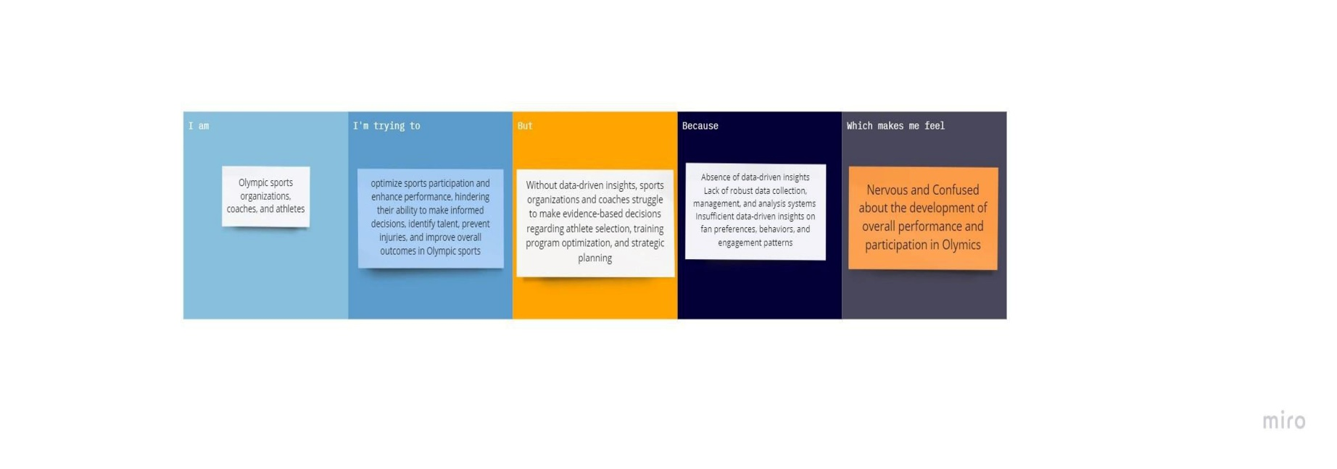

|  |  |  |  |  |  |
| --- | --- | --- | --- | --- | --- |
| **Problem Statement (PS)** | **I am (Customer)** | **I’m trying to** | **But** | **Because** | **Which makes me feel** |
| PS-1 | coach | Optimize training strategies | struggle to effectively track and analyze athlete performance data in Olympic sports | I lack in data | Confused and sad |
| PS-2 | stakeholders | Identify opportunities for increased diversity and incusivity | lack comprehensive and easily accessible data-driven insights on Olympic sports participation trends | Data analyzers | low |
| PS-3 | Athlete | Trying to integrate wearable technology and data analytics to monitor and improve performance | Its difficult for me to choose | Limiting my ability to leverage technological advancements in olympic sports | Confused and lost |